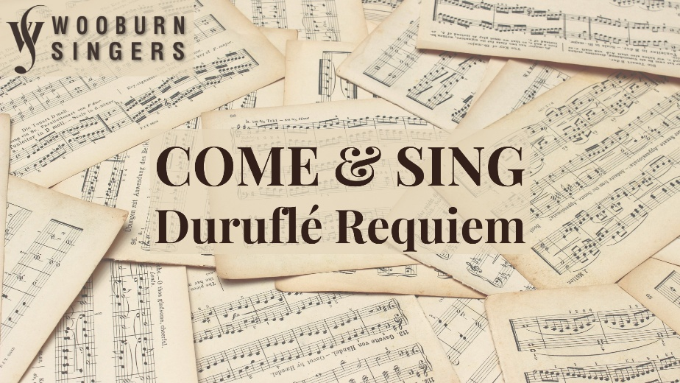
Conductor: Jonathon Cole-Swinard
Accompanist: Simon Howat

Saturday 3rd October 2026
The Beaconsfield School, Wattleton Road, Beaconsfield, HP9 1SJ

Registration from 9:45am for 10:30 downbeat;
Performance 4:30 pm (family & friends welcome); 5:30 pm finish

Tickets: £20 (£15 for groups of 10+, students £5)
includes coffee/tea & loan of score if required

Ploughman’s lunch option available for £9
(must be pre-booked and prepaid by 26th September)

To register, please email the completed form to WooburnSingersComeandSing@gmail.com & arrange online payment to Wooburn Singers, sort code 30-96-54, account no. 01029546. Please quote CandS as the reference.

Alternatively, post the form below to:
Wooburn Singers, c/o Stable Cottage, Finch Lane, Beaconsfield HP9 2TL
enclosing a cheque payable to Wooburn Singers

For more information & map go to www.wooburnsingers.org.uk

*****************************************************************************************
Wooburn Singers - Come and Sing Duruflé Requiem - Registration

Name: ____________________________ Choir (if applicable):____________________

Email: ___________________________________ Telephone: ____________________
Voice Part: S / A / T / B; 1st / 2nd when divided (delete as appropriate)

I need to borrow a score (Durand edition) / I will bring my own score (delete as appropriate)

Quantity |  | Total
 | tickets @ £20 | £
 | tickets @ £15 | £
 | tickets @ £5 | £
 | lunches @ £9 | £
GRAND TOTAL |  | £
Payment

Paid online / Cheque enclosed (delete as appropriate)

