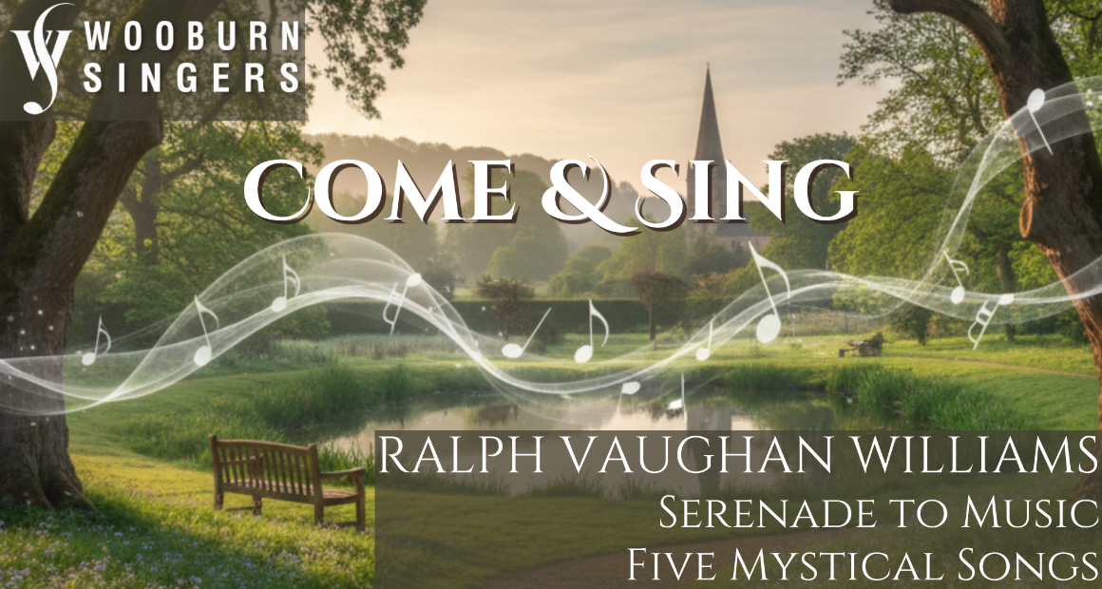
Conductor: Jonathon Cole-Swinard
Accompanist: Simon Howat

Saturday 31st January 2026
The Beaconsfield School, Wattleton Road, Beaconsfield, HP9 1SJ

Registration from 9:45am for 10:30 downbeat;
Performance 4:30 pm (family & friends welcome); 5:30 pm finish

Tickets: £20 (£15 for groups of 10+, students £5)
includes coffee/tea & loan of score if required

Ploughman’s lunch option available for £8
(must be pre-booked and prepaid by 24th January)

To register, please email the completed form to WooburnSingersComeandSing@gmail.com & arrange online payment to Wooburn Singers, sort code 30-96-54, account no. 01029546. Please quote CandS as the reference.

Alternatively, post the form below to:
Wooburn Singers, c/o Stable Cottage, Finch Lane, Beaconsfield HP9 2TL
enclosing a cheque payable to Wooburn Singers

For more information & map go to www.wooburnsingers.org.uk

*****************************************************************************************
Wooburn Singers - Come and Sing Vaughan Williams- Registration

Name: ____________________________ Choir (if applicable):____________________

Email: ___________________________________ Phone: ____________________

Voice Part: S A T B / 1st / 2nd (delete as appropriate)

Five Mystical Songs: I need to borrow a score (Stainer & Bell) / I have my own (delete as appropriate)
Serenade to Music: I need to borrow a score (OUP 1938) / I have my own (delete as appropriate)

Payment: __ tickets at £20 / __ tickets at £15 / __ tickets at £5 £_______
__ Ploughman’s lunches at £8 £_______
Paid online / Cheque enclosed (delete one) total £_______

