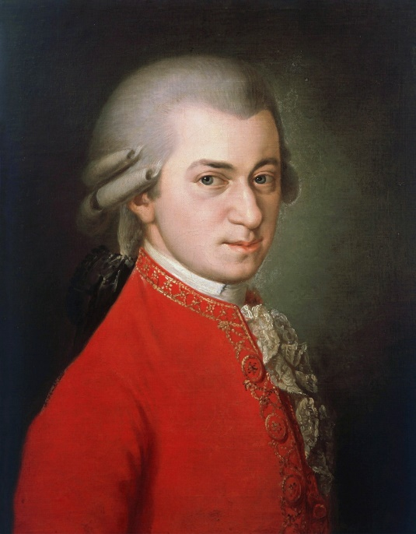


Come and Sing
Sat 7th October 2023
Wolfgang Amadeus Mozart
Mass in C Minor

Conductor: Jonathon Cole-Swinard
Accompanist: Simon Howat

The Beaconsfield School, Wattleton Road, Beaconsfield, HP9 1SJ

Registration from 9:45am for 10:30 downbeat; Performance 4:30 pm
(family & friends welcome); 5:30 pm finish

Tickets: £20 (£15 group rates, students £5) includes coffee / tea, and loan of score if required

Ploughman’s Lunch option available for £7.50 (must be pre-booked and prepaid by 2nd Oct)

To register, please email the completed form to wooburnsingerscomeandsing@gmail.com & arrange online payment to Wooburn Singers, sort code 30-96-54, account no. 01029546.
Please quote CandS as the reference.

Alternatively, post the form below to:
Lynda Weiss, 106 Deanway, Chalfont St Giles, HP8 4LQ
enclosing a cheque payable to Wooburn Singers

For more information & map go to www.wooburnsingers.org.uk

*****************************************************************************************
Wooburn Singers - Mozart: Mass in C Minor: Come & Sing Registration

Name: _______________________________ Choir____________________

Email: _______________________________ Phone: ___________________

Address: (only need if no email address)___________________________________

___________________________________________________________

Voice Part: S A T B / 1st / 2nd (delete as appropriate)

I need to borrow a score (Peters edition) / I have my own (delete as appropriate)

Payment: __ tickets at £20 / __ student tickets at £5 £_______
__ Ploughman’s lunches at £7.50 £_______
Paid online / Cheque enclosed (delete one) total £_______

