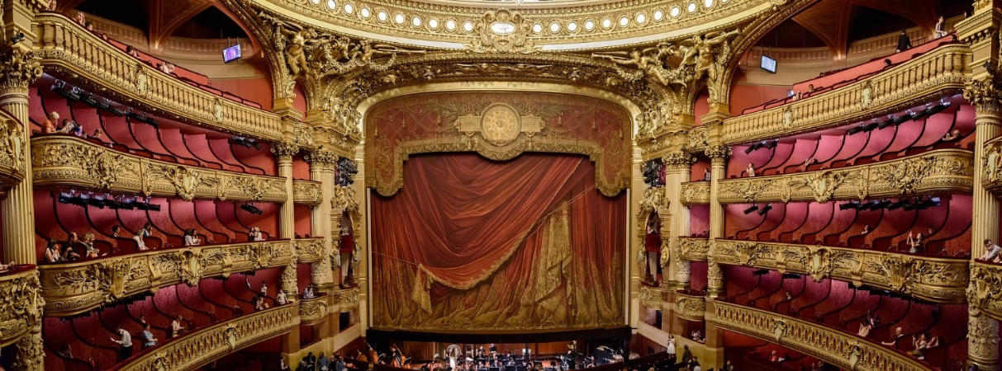
Come and Sing: Favourite Opera Choruses

Conductor: Jonathon Cole-Swinard
Accompanist: Simon Howat

Saturday 4th February 2023
The Beaconsfield School, Wattleton Road, Beaconsfield, HP9 1SJ

Registration from 9:45am for 10:30 downbeat;
Performance 4:30 pm (family & friends welcome); 5:30 pm finish

Tickets: £20 (£15 for groups of 10+, students £5) includes coffee/tea, and loan of score if required

Ploughman’s Lunch option available for £7 (must be pre-booked and prepaid by 1st February)

To register, please email the completed form to WooburnSingersComeandSing@gmail.com & arrange online payment to Wooburn Singers, sort code 30-96-54, account no. 01029546. Please quote C&S as the reference.

Alternatively, post the form below to:
Wooburn Singers, c/o Stable Cottage, Finch Lane, Beaconsfield HP9 2TL
enclosing a cheque payable to Wooburn Singers

For more information & map go to www.wooburnsingers.org.uk

*****************************************************************************************
Wooburn Singers - Come and Sing: Favourite Opera Choruses - Registration

Name: _______________________________ Choir____________________

Email: _______________________________ Phone: ___________________

Address: (only need if no email address)___________________________________

___________________________________________________________

Voice Part: S A T B / 1st / 2nd (delete as appropriate)

I need to borrow a score (Oxford Choral Classics: Opera Choruses - OUP) / I have my own (delete as appropriate)

Payment: __ tickets at £20 / __ tickets at £15 / __ tickets at £5 £_______
__ Ploughman’s lunches at £7 £_______
Paid online / Cheque enclosed (delete one) total £_______

