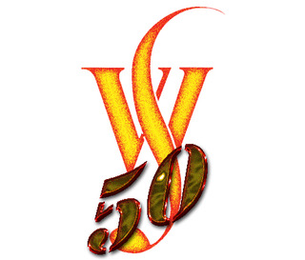
You are cordially invited to join us for
Wooburn Singers 50th Anniversary Concert and Party
When? Saturday 17th June 2017 at 7pm
Where? All Saints Church, The Causeway, Marlow, SL7 2AA
& reception afterwards at the Shelley Theatre,
Court Gardens, Pound Lane, Marlow, SL7 2AE
What? A celebratory programme of music from all eras, with all
former members invited to join us for two items (Parry: I was Glad & Handel: Zadok the Priest with short rehearsal on the day: 4.30-5pm tbc).
followed by wine, cake & conversation at the Shelley Theatre (8.30-10.30)
Conductors: Tom Hammond-Davies & Greg Beardsell
How much? £20 inclusive of concert & party (under 18s free)
How? See website for further details www.wooburnsingers.org.uk
Or get tickets from any member of the choir or on-line.
Or telephone: 01494 722017
If you would like to sing, please use the booking form supplied
or email 50years@wooburnsingers.org.uk .
Further information for singers will be sent out separately.
Please forward this invitation to any past Woobies you know.

